

Family Expense Tracker
Project Report Submitted
in Partial Fulfillment of the Requirements
for the Degree of

Bachelor of Engineering
in

Computer Science & Engineering

by

Student Name - Ishu Thakur

Student ID - 1711981124

COMPUTER SCIENCE & ENGINEERING
CHITKARA SCHOOL OF ENGINEERING & TECHNOLOGY
CHITKARA UNIVERSITY, HIMACHAL PRADESH, INDIA

18thApril, 2019

Acknowledgement

The success and final outcome of this project required a lot of guidance and assistance from many people and I am extremely privileged to have got this all along the completion of my project. All that I have done is only due to such supervision and assistance and I would not forget to thank them.

I respect and thank Dr. Nitin Verma for providing me an opportunity to do the project work in Family Expense Tracker and giving us all support and guidance which made me complete the project duly. I am extremely thankful to him for providing such a nice support and guidance, although he had busy schedule managing the corporate affairs.

I owe my deep gratitude to our project guide Mr. Shankar Aggarwal, who took keen interest on our project work and guided us all along, till the completion of our project work by providing all the necessary information for developing a good system.
I am thankful to and fortunate enough to get constant encouragement, support and guidance from all Teaching staffs of CSE which helped us in successfully completing our project work.
Ishu Thakur.

- Introduction

There has been a change in plans the budgeting is no longer an action limited to governments, corporations and authorities, but rather extends to include families as social entities with multiple socio-economic goals. Budgeting brings considerable benefits to the family, whether on daily basis, short term or long term benefits, where the family plans for both the present and future.
The current trend of research on bugeting being extremely relevant to family's economic and social concerns, family budgeting is worthy to be studied. To this end, we are keen to provide a simple and clear explanation for budgeting process as well as its items, including expenditures, revenues, savings and investments.

Several variants of algorithms have been developed for bugeting . The current research is to study and develop algorithms on the problem that Many families in the country are still reluctant to do a budget. As distasteful as the taste many seen, yet, it is important to map out our expenses and purchase so that we can see just where our money is going. It indicates the standard of living of the family as it represent an overall picture of income and expenditure, this can be done by establishing a good family budget.
Family budget is the surest way to get families out of financial mess or debt if budgeting can be done efficiently.

- Motivation

Motivation goes here that Family money management isn’t too different from managing a budget as a single person or even as a couple. The biggest thing you need to think about is where your expenses are, and if you need to rethink your spending. After all, kids are expensive. One estimate shows that the cost of raising one child to age 18 is almost a quarter of a million Rupees! So, you need a family budget to ensure you can maintain financial stability as you raise your kids.

- Related work

The previous work related to this project was:-
- Entering the dataset in Excel Spreadsheet.
- Filtering the dataset according to the requirements.
- Analyzing the database to describe the factors responsible.

- Proposed Method

In this section we describe a way to solve the problem of Family Expense Tracker in number of steps :

Step 1 :
Write it down
The first step in budgeting is to write down the various sources of your income. This includes salary, rent, interest on deposits, dividends, etc. Then make a list of expenses incurred in a month and allocate money to each of these heads. Include everything, from the grocery bill to what you pay the maid, from the fuel expenses to the EMI of the car.

Step 2 :

Determine Your Income
Get out copies of each of your pay stubs. Add your net salaries together to determine how much money you each earn each month. Add any additional income that you regularly earn every month. Write your monthly income figure at the top of your notepad.
Step 3:

Calculate Leftover Amount
Subtract your monthly expenses from your monthly income to determine how much you have left over each month. Compare the amount you have left over with your monthly savings goal.For example, if you have $200 left each month. Plan to cut an additional $100 from your monthly budget, as you would be $100 short of your savings goal.
Step 4 :

Plan Spending
Plan how you will cut your chosen variable expenses. Buy fewer name brand products, for example, to save the extra $50 on groceries. Form a carpool with your work buddies to save on gas.

Step 5 :

Monitor Your Budget
Draft a copy of your new budget, including the reduced variable expenses. Check your budget against actual expenditures each week to make sure you are staying within your spending parameters.

- Methodology

The methodology used in this proposed work is datasets of family expense tracker is analyzed to get different tables and charts and to get the different factors responsible for this. The data is in the form of Microsoft Excel. The analysis for different factors of family expense tracker was done using making charts and tables and using some formulas to get the formulated result.

ITERATIVE PROCESS
It is certainly an effective budgeting methodology. The process mainly involves you implementing top-down and bottom-up budgeting methodologies. The only difference is that once your employees are done with both of those budgets, they are analysed, compared with one another, negotiated and finally, reconciled.All of the benefits of top-down and bottom-up are at work here. There is plenty of information flowing between all levels of the company so upper management can better see how money is spent on the more tertiary level and lower employees can understand what upper management is looking for in terms of spending and there can be no miscommunications between lower management and upper management.

- Analysis

- The best way to develop an accurate family budget is to be very familiar with your current and past expenses.

- You may be doing one or a combination of the following: 1) drawing an amount from the farm checking account to pay family living expenses each month; and/or 2) using non-farm income to pay all or a portion of family living expenses.

- After determining this amount, list the expenses you incur each month that are
known, or fixed.

- After establishing these amount, subtract the total of these known expenses from the total amount the family spent. The remainder will be those expenses that vary from month to month.

- Next, based on your memory, cashed checks, and other records you may have, allocate the remainder to the family living expense categories that vary from month to month. As shown in
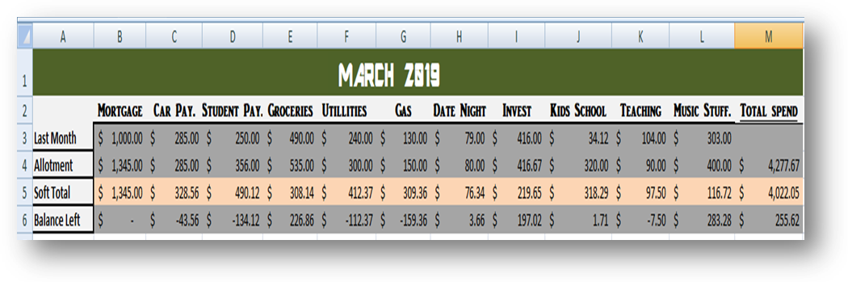

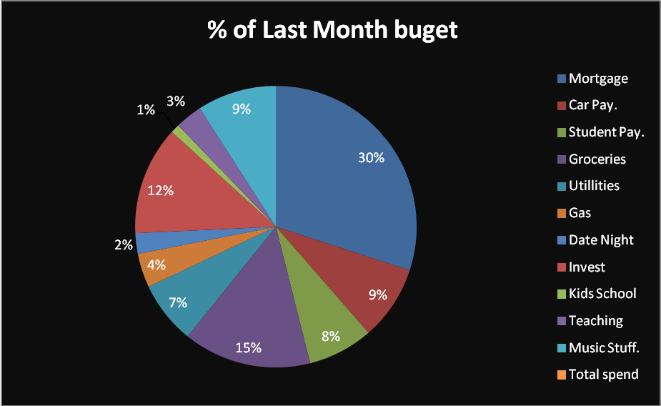

Budgeting Income

- To begin, list all sources and estimated amounts of income you expect to have available for family expenses during the year.
- These include salaries, interest income, rental income, dividends, non-farm business income, etc. As shown below
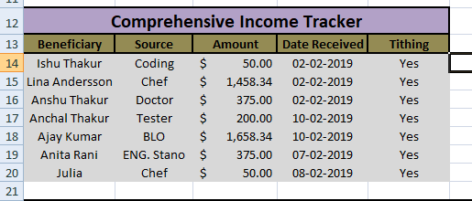

Budgeting Expenses

- Since there are so many types of family living expenses, so determine the categories that are meaningful to family.

- For simplicity, they should be consistent with the categories you use in your record-keeping system.

- The next step is to budget an amount for each of your expense categories that reflects the goals, lifestyle and desired standard of living your have established. As shown in
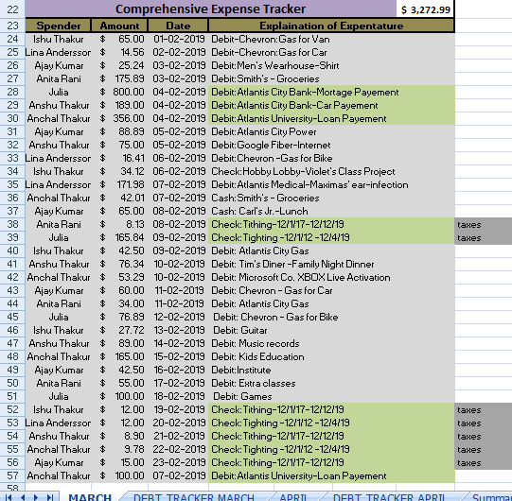
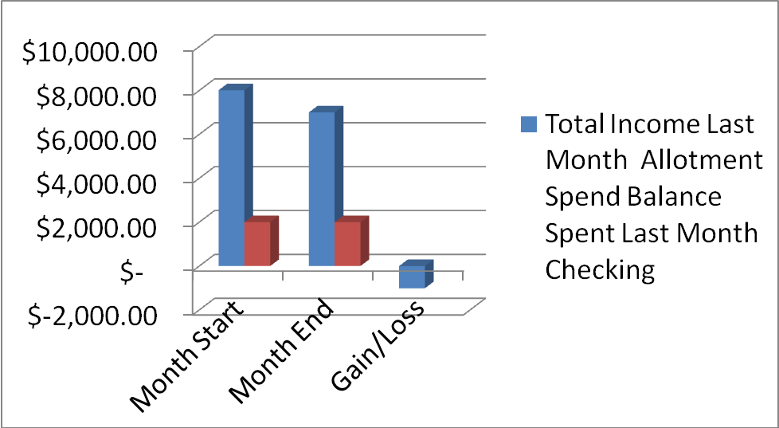

GAIN/LOSS

- Steps in determining if there is a budget surplus:
    - Make sure you have not underestimated some of your expenses or overestimated income.
    - Apply the surplus to debt.
    - Reinvest the surplus.
    - Invest the surplus in a retirement fund or college savings fund.
    - Increase your standard of living and/or family goals.
- Steps in determining if there is a budget deficit:
    - Make sure you have not drastically overstated any of the expenses or underestimated income.
    - Re-evaluate your family’s goals and desired standard of living. You may need to lower them.
    - Determine whether you can decrease expenses while still meeting your goals and standard of living. You will more than likely have to make some tough choices to accomplish this.
    - Determine whether you can generate more income. If you can, then determine if it will be enough to cover the deficit. If it is more than enough, you will need to determine how you want to spend the excess (surplus).
AS SHOWN IN

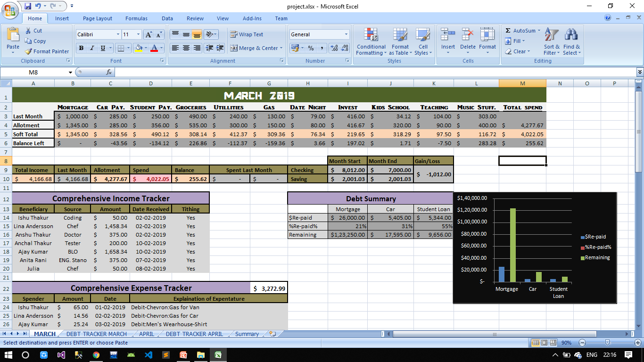

COMPARISION OF BALANCE PAID

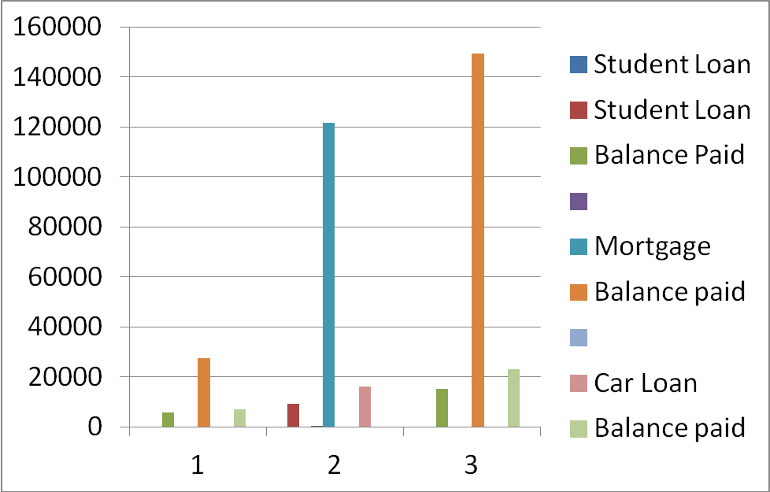

In the chart given below we get to know about on which thing we have spend much in which month and can also compare how we have spend on a particular month

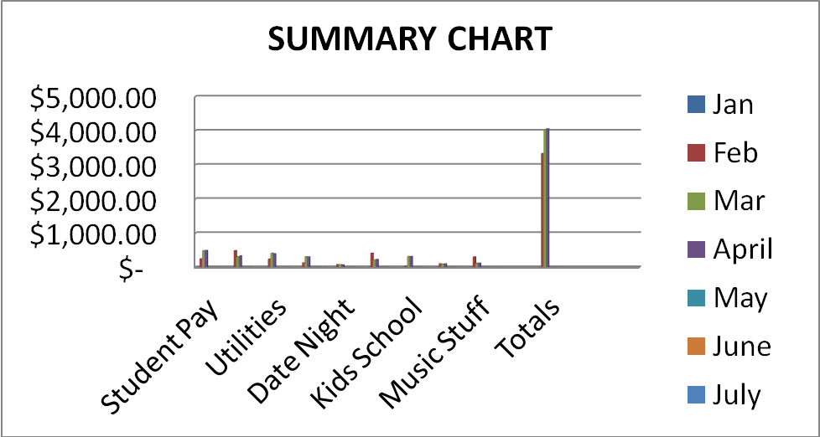

- Plan of work(Timeline)

WEEKS | PROJECT  ALLOCATION | ENTERING  DATABASE IN EXCELSHEET | PREPARING  CHARTS | ANALYZING THE DATABASE | COMPLETION
WEEK1
WEEK2
WEEK3
WEEK4
WEEK5
WEEK6
WEEK7
WEEK8
WEEK9
WEEK10

References

https://www.data.gov.in/
https://www.kaggle.com/
www.datasciencecentral.com

